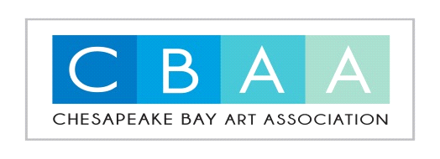
Chesapeake Bay Art Association Application for Membership 2023

Name ________________________________________________
Email ________________________________________________
Address _______________________________________________
Phone/Cell ____________________________________________
Describe the process and style of work you do:
_____________________________________________________________________________________
Medium:_____________________________________________________________________________
New member’s dues are $20.00. You will need to submit 3 photos of your work to the Membership committee and a copy of this application to cbaamembership757@gmail.com for a jury of membership acceptance. Members who are renewing their membership will pay $20.00 by the end of February. If paid after March 1, Dues are $30.00. Your dues may be sent by mail (732 Rochelle Arch, Virginia Beach, VA 23464), paid in person at our monthly meetings, or you can request an electronic invoice by emailing mit12300@gmail.com. Meetings are the third Tuesday of each month. Locations may vary. Please watch for the update via email. Make checks out to CBAA.
Members are encouraged to serve on a committee. Please check 3 committees that you can assist in helping.
Art Shows ____ Student Scholarship _____ OV Art Show _____ Advertising _____
Hospitality ____ Newsletter ______ CBAA events _____
Membership _____ Student Tent (OV) ____ Internet/social media _____
We all look forward to having you join us at the next meeting. Meetings are very important. We need all of our artists to be active and keep our organization running. We need and value everyone’s input. Thank you for being a part of what makes CBAA great!

